EIGENFACES
DEGREE IN DATA SCIENCE AND ENGINEERING

Alejandro Perez
Christopher Manzano
03.11.2020
STATISTICAL LEARNING

INTRODUCTION
We have created two classifiers using pca, knn and our knowledge of statistics and data science. First of all we created the functions pca and classifiers. Then we used cross validation to get that k should be 1 and the distances should be between euclidean and manhattan.
Then we generated a data set (containing the predictions, the true labels and the distance) for approximating the distribution of the distance of the images correctly classified and the distribution of the distance of the predictions that should be 0.
Finally we simulated a confidence interval by taking the percentile x of the distances in a determined configuration. We hope you find this report interesting.

PROCEDURE
We have used our matrices of image-vectors : images, images95 and images87 (at its percentage of variance and scaled in the cases of images95, and images87). We also changed the name of the images which only have one number to two so they could be ordered (1AT.jpg -> 01AT.jpg)
We have three folders: images (contains the images you gave us), plots(contains the most relevant plots we made), rdata(‘contains all the ‘*.RData’ files. In addition, we have the file classifiers.R which contains the code for executing the classifiers from the exercises b and d. Finally we have the main.R file which contains most of the code of the exercises a,b and d. (c is the procedure in this report, and d is our conclusion).

Exercise A
We created the function pca(X, center = T, scale = T). This function takes a matrix of numbers and uses the function eigen to get the eigenvectors and the eigenvalues of the correlation or variance-covariance (depending whether you want to scale or not) matrix which was obtained by multiplying the data matrix by its transposed. Finally, it returns a list containing the matrix of eigenvectors P, the vector of eigenvalues D and the mean used to center the data.

Exercise B
In order to build the classifier, we used a beta classifier (which takes images already processed and can classify more than one image at call) for determining the different parameters.
We put that beta classifier into a loop using cross validation on the full data set to get the values of k (amog 1 and 5) and the distance method (euclidean, manhattan or maximum). We finally got k = 1 is by far the best option. And the distance method was among euclidean and manhattan which gave quite similar results.
Therefore, we were going to decide which method to use taking into account the distribution of the distances that they give us.
We set up another loop which takes out a person (six images) of the data set, assigns those images the true label 0 and joins them to the images that are going to be predicted.
The true labels, the predictions and the distance at each iteration were saved into a matrix. Then they were labeled by its method (euclidean at 87 percent of variance retained, euclidean at 95, manhattan at 87 or manhattan at 95).
We joined the four matrices into a data frame. We scaled the distances of each matrix. Also, we separated the data into 2, data which had true labels equal to predicted labels (so the distances are real) and data which had true labels equal to 0 (all 0 labels are wrong since it was impossible to get a prediction of 0 before, thus they can not be in the first part of the data).
We finally plotted boxplot for each method with the first part of data, and another with boxplot for each method with the second part of the data:
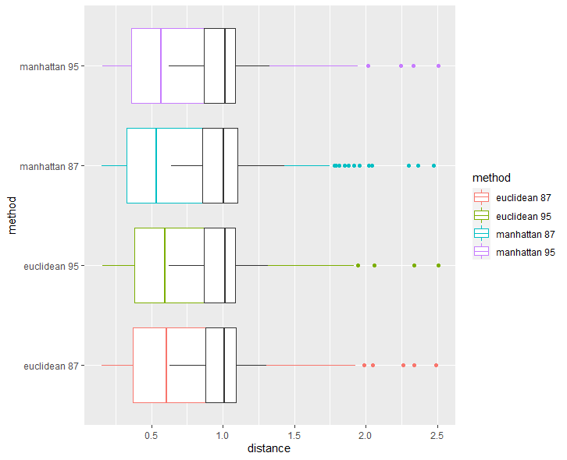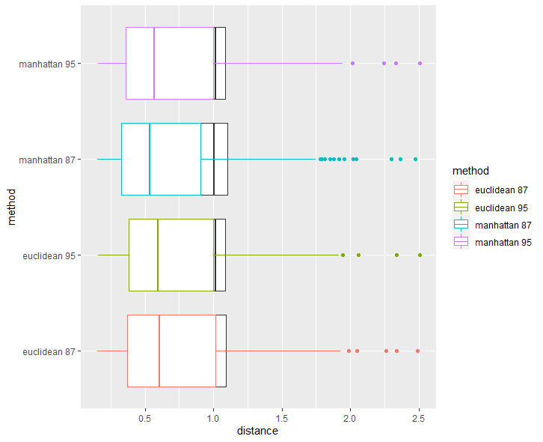
Here we can see that the manhattan method at 87 percent of variance (cian plot) is the one who has the true distances more skewed and separated from the its 0 labels distances (black plot)

We take out the other distance methods and conserve the values of the distances without scaling them:
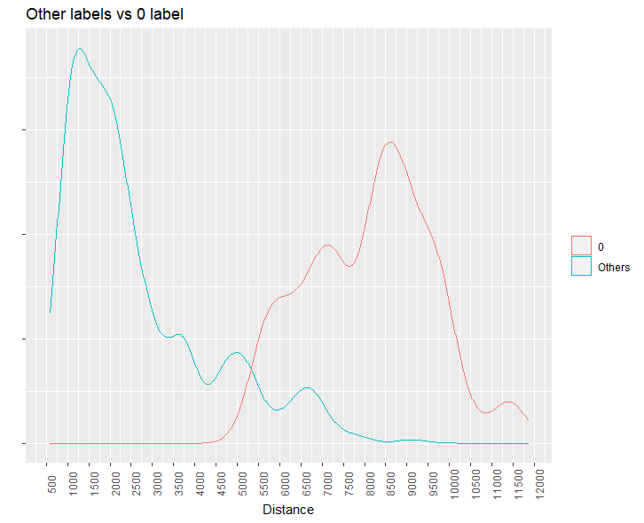
Finally we set the threshold to be the percentile 97.5 of the blue distribution (which contains true distances). Why this? Because it maximized our accuracy. We have to remember that even if we have the distribution red as an approximation, it may differ quite at all from the real distribution, thus we prioritized recognizing the images of the dataset.
parameters.pca = list(x = images87[,-1], y = images87[,1], k =1, method = 'manhattan', threshold = 6752.141, similarity = F, pca.var=87, scale = T, Center = T)
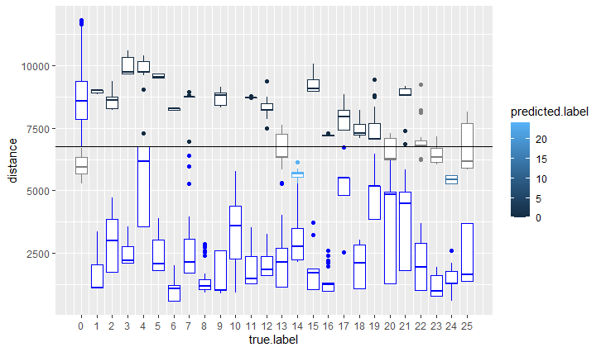Reaching an accuracy more or less equal to 86.76 percent

Exercise D
We did the same as in the exercise B and we got these results:
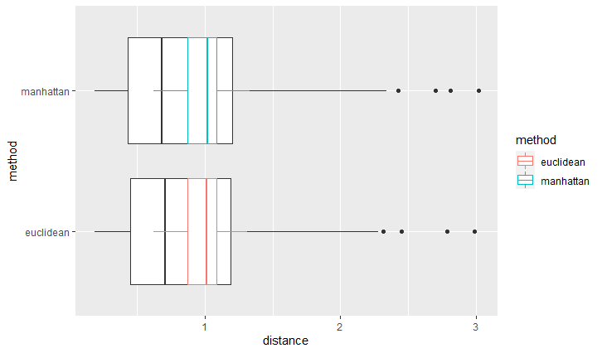
The results are quite similar, we decided to choose the euclidean. But we would need more research for determining the best distance. Sadly because of some organization problems we could not do them.
The distribution of the euclidean distance is:
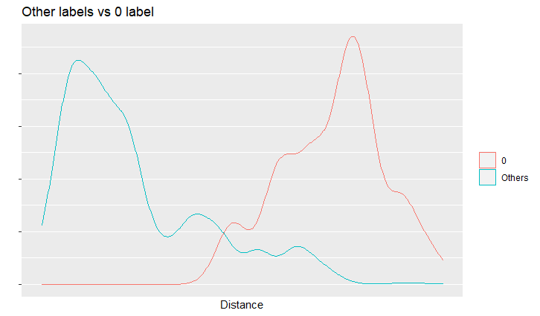We take the percentil 97.5 and we got that the threshold should be 57.90. Thus:
parameters = list(x = images[,-1], y = images[,1], k =1, method = 'manhattan', threshold =57.9, similarity = F, pca.var=100, scale = F, Center = F)
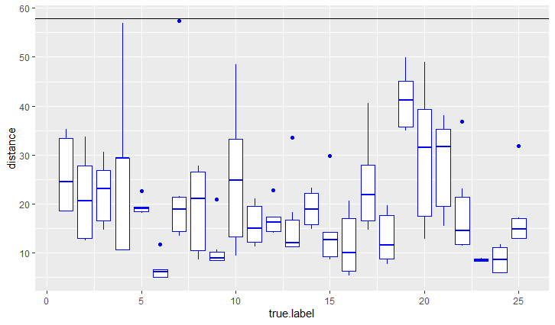
We got an accuracy around 100 percent without the 0 label

CONCLUSION
Since we got more accuracy at the classifier without pca, but we think that it is risky to bet for this classifier without using the 0 labels even if it works really well with the threshold
We prefer to use the pca version, because we think it can reduce noise in the images. Also it provides a lighter version of the image which in terms of space and speed are better than saving the whole image. Last but not least, we did not have enough time to analyze the classifier with the full images deeply. The pca version is more tested and accurate in our opinion.
We hope you found this report as interesting as we found this project. This was a big challenge, we had to write a lot of code, think of ways to estimate the threshold, we had to execute for whole nights the code (even we lost the data saved, and we had to start again all the steps). But we are happy with the results. We think our skills improved a lot. We deeply understand what is going on inside pca and knn. It is kind of cool thinking that we can build an image recognizer. Thus we think it was worthwhile.
Thanks for reading

